Information about Residential Conferences at Oregon State University
OSU Chamber Music Workshop – Summer 2014
Accommodations
We will be offering on-campus accommodations from July 6-19, 2014. Participants will be staying in the Weatherford Hall, located at the corner of Jefferson Avenue and 26th Street.
Typical Weatherford room layout
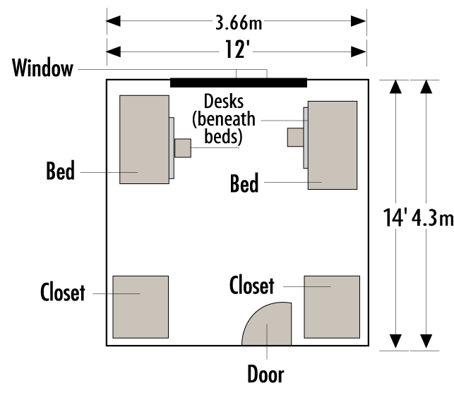
Amenities
- Bed linens and towels
- Wireless internet access throughout the building
- Cable television in the lounges
- On-site laundry facilities
- 24-hour/day staffing

Keys and security
When they check-in, participants will be issued a key for their room only. The residence halls are locked 24/7 and participants will only be able to enter the hall with an adult chaperone or staff. Lost keys cost $50.
Residence hall policies
All guests are expected to abide by UHDS policies, found here: http://oregonstate.edu/uhds/uhds-policy-guide.

Dining
Guests will eat at one of our dining halls on-campus, conveniently located near each of our residence halls. We offer fast, friendly service in cafeteria or food court style design that offers flexibility for our guests. We have fresh meat, vegetarian, and vegan food selections, made to order to satisfy guests' tastes and preferences. We also have dietitian services available to help assist with special dietary considerations in UHDS dining center. Upon check-in, guests will receive a meal card, preloaded with the meals included during their stay. They will need to have this card at each meal.
Oregon State is a smoke-free campus.
For more information, please visit: http://oregonstate.edu/smokefree.
Parking
Parking permits are required on the OSU campus Monday through Friday 7am-5pm. Please visit the Parking Services webpage to learn more and to purchase parking permits: http://parking.oregonstate.edu/

